Project 1 documentation Computer Vision – Gabor Stefan

In the first step, I took a good image of the board, from where I cropped only the board game where the pieces of the Dominoes will be placed. From this I extracted almost perfectly the board template specifying the board coordinates, and fit the board on a image.
From that I used Lab 4 methods:
Get_key_points_and_features , match features, generate_homography, and stitch images in order to bring all game images on board template format, like this:
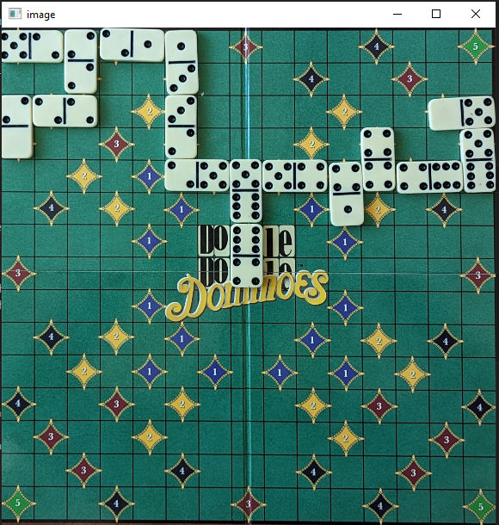
After that I used get_patches and find_patches template methods from Lab 2 to get all squares, separately from each image. On find patches images, I made some modifications, in order to fit my needs, for getting all squares/ game fields.
On the next step, I got all possible pieces faces, from 0 to 6 from the next image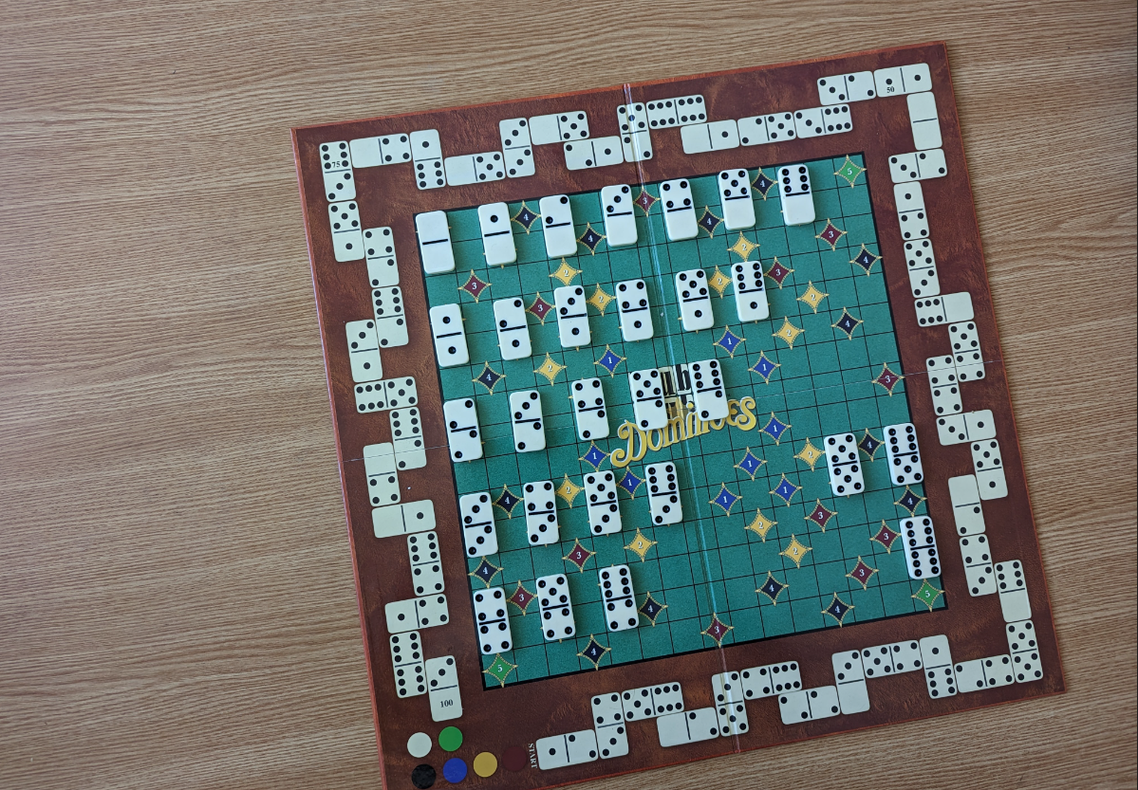

Using the methods mentioned before.
Next I wanted, from the first move, looking on the center of the table, and fields near them, to check on which field, a piece has been placed by a player, using the move image, board patches and patches with a half of a piece (numbers from pieces from 0 to 6)

